“Divinely Superfluous Beauty:”
Multi-Genre Thematic Comparisons
in the short fiction & non-fiction of John Steinbeck,
poetry of Robinson Jeffers,
and photographs of Edward Weston

Alison E. Kreiss
Choteau High School, Choteau, Montana
NEH Steinbeck Institute 2013

- Overview:
  - One of the many theories of Steinbeck’s friend and collaborator, Edward F. Ricketts, was the concept of cultural peaks and convergences in time and place. It could be argued that the artistic output of the Monterey Peninsula, Big Sur, and Carmel areas of the 1930s represents one of these peaks, producing diverse visions unified by place and breeding common themes about the boundaries of wilderness and civilization, ecology, and a pantheistic vision of the world.

    - This could be a stand-alone lesson or integrated within a longer poetry, visual arts or Steinbeck unit.
    - Minimum time required: 3-4 class periods; could be extended to up to ten days if all sources are used.
    - Adaptable for grades 9-12
    - Primary Common Core Standards Addressed:

- CCSS.ELA-Literacy.RL.9-10.7 Analyze the representation of a subject or a key scene in two different artistic mediums, including what is emphasized or absent in each treatment (e.g., Auden’s “Musée des Beaux Arts” and Breughel’s Landscape with the Fall of Icarus).
- CCSS.ELA-Literacy.W.11-12.9a Apply grades 11–12 Reading standards to literature (e.g., “Demonstrate knowledge of eighteenth-, nineteenth- and early-twentieth-century foundational works of American literature, including how two or more texts from the same period treat similar themes or topics”).

- Suggested Procedures:
  - Geographical Orientation: Provide students with a geographical orientation to the area using Google Earth maps, Steinbeck Institute photos, and artist Jo Mora’s painting “Monterey Peninsula” http://www.raremaps.com/gallery/detail/22063?view=print
  - Introduce students to Robinson Jeffers with Edward Weston’s portrait of him, available here: http://www.sonnets.org/jeffers.htm
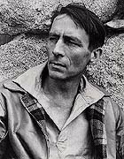
  - In conjunction with Jeffers’ biography, show the April 4, 1932 Time Magazine cover: http://content.time.com/time/covers/0,16641,19320404,00.html
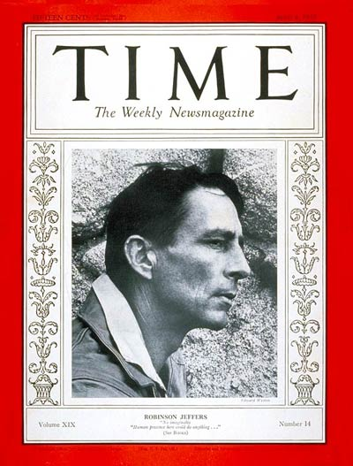

  - Use selections from the biography and photo gallery from the Robinson Jeffers Association: http://www.robinsonjeffersassociation.org/
  - A concise background to Jeffers’ work can be found at the NEA Big Read:
http://www.neabigread.org/books/jeffers/readers-guide/. This contains a useful definition of “inhumanism.”

- Suggested Jeffers poems (with page numbers from Selected Poems, Vintage, 1963)
    - “To the Stone Cutters” (p. 3)
    - “Boats in a Fog” (p. 37)
    - “Tor House” (p. 44)
    - “Return” (p. 60)
    - “The Excesses of God” (p. 72)
    - “Calm and Full the Ocean” (p. 84)
    - “Carmel Point” (p. 102)

- In conjunction with reading Jeffers “site specific” poems above, show students selected photographs from Edward Weston’s My Camera at Point Lobos: “Cypress Grove, Point Lobos;” “Point Lobos, 1930;” “Big Sur.” Guide students toward making connections between Weston’s images and Jeffers’ poems.
- Transition to Steinbeck with his 1932 portrait taken by Weston’s assistant, Sonya Noskowiak:
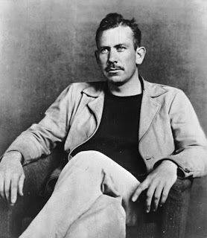

Collection Center for Creative Photography. ©1981 Arizona Board of Regents.

- Suggested Steinbeck selections: “The White Quail” and “Flight” from The Long Valley; Chapter #31 from Cannery Row (the lonely gopher); Chapter #14 from The Log from The Sea of Cortez (Easter Sunday); Chapter #25 from The Grapes of Wrath. Assign these passages with the task of identifying themes they may share with Jeffers and Weston.
- Supplementary Readings:
  - “Bohemian Carmel: Modernism in the West”, chapter #8 of Susan Shillinglaw’s A Journey into Steinbeck’s California.
  - “In Point Lobos, Where Edward Weston Saw the World Anew” http://www.nytimes.com/2009/03/29/travel/.html?pagewanted=all&_r=0
  - From the Monterey County Weekly, preview of the “Jeffers and Steinbeck: Habitat of Thought” exhibit at the National Steinbeck Center:
http://www.montereycountyweekly.com/news/cover/article_bc18214a-3686-5b01-b171-

- Discussion Questions:

  - Steinbeck wrote to his editor: “I cannot write the poetry of Jeffers, but I know the god better than he does.” He also complained that Jeffers had taken the California landscape and “translated it into the symbols of Pittsburgh.” Compare this attitude with Montana poet Richard Hugo’s idea that “the outsider sees more clearly than the insider.”
  - Steinbeck writes in The Log from The Sea of Cortez: “Ecology has a synonym which is ALL” (72). Cite a parallel idea in one of Jeffers’ poems.
  - Can Jeffers assertion of “a great humaneness at the heart of things” (“The Excesses of God”) be reconciled with his command: “We must uncenter our minds from ourselves; / We must unhumanize our views a little” (“Carmel Point”)?
  - How would Jeffers, Weston, or Steinbeck respond to Frank Lloyd Wright’s quote: “I believe in God, only I spell it Nature”?
  - How does Jeffers express the idea of an “American Sublime”? How do his poems affirm the Romantic need for the violence and beauty of nature?
  - Compare and contrast the boundaries of wilderness and civilization as depicted in either Steinbeck’s “The White Quail” or the gopher chapter from Cannery Row with Jeffers’ “Carmel Point.”
  - Edward Weston aimed to capture “the life force within the form” in his photographs. How could this be considered a “visual rendering of Steinbeck’s nonteleological acceptance of what ‘is’” (Shillinglaw, 138)?
  - How is Jeffers “inhumanism” aligned with Steinbeck’s goal of seeing humans as part of a larger whole in his fiction (Shillinglaw, 136)?

- Assessment:
  - In a well-developed and textually supported 2-3 page essay, identify and analyze a common theme among a Weston photograph, Jeffers poem, and Steinbeck passage.

Sources

Bennet, Melba Berry. 2007. The Stone Mason of Tor House: The Life and Work of Robinson Jeffers. Carmel, California: The Tor House Foundation.
Jeffers, Robinson. 1963. Selected Poems. New York: Vintage.
Shillinglaw, Susan. 2011. A Journey into Steinbeck’s California. Berkeley, California: Roaring Forties Press.
Steinbeck, John. 1994. Cannery Row. New York: Penguin.
Steinbeck, John. 1995. The Long Valley. New York: Penguin.
Steinbeck, John. 1995. The Log from the Sea of Cortez. New York: Penguin.
Steinbeck, John. 2006. The Grapes of Wrath. New York: Penguin.
Weston, Edward. 1968. My Camera on Point Lobos. DeCapo Press

